**Date: 23rd January 2023**

# EXPERIMENT-3

**TITLE: DDL (Data Definition Language) commands with Data Constraints**

**Objective:** To understand the concept of data constraints that is enforced on data being stored in the table. Focus on Primary Key and the Foreign Key

# Create the tables described below:

# Table name: CLIENT_MASTER_1

**Description:** used to store client information.

|  |  |  |  |
| --- | --- | --- | --- |
| **Column name** | **data type** | **Size** | **Constraints** |
| CLIENTNO | Varchar | 6 | Primary key / first letter must start with ‘C’ |
| NAME | Varchar | 20 | Not Null |
| ADDRESS 1 | Varchar | 30 |  |
| ADDRESS 2 | Varchar | 30 |  |
| CITY | Varchar | 15 |  |
| PINCODE | Integer | 8 |  |
| STATE | Varchar | 15 |  |
| BALDUE | Decimal | 10,2 |  |

**Query:**

use ravidb;

create table CLIENT_MASTER_1 (

CLIENTNO varchar(6) primary key,

NAME varchar(20) not null,

ADDRESS1 varchar(30),

ADDRESS2 varchar(30),

CITY varchar(15),

PINCODE int(8),

STATE varchar(15),

BALDUE decimal(10,2),

constraint c_chk check(CLIENTNO like 'C%')

);

desc CLIENT_MASTER_1;

**Output:**

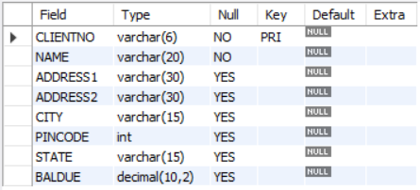

**Table Name: PRODUCT_MASTER_1 Description:** used to store product information

|  |  |  |  |
| --- | --- | --- | --- |
| **Column name** | **data type** | **Size** | **Attributes** |
| PRODUCTNO | Varchar | 6 | Primary Key/ first letter must start with ‘P’ |
| DESCRIPTION | Varchar | 15 | Not Null |
| PROFITPERCENT | Decimal | 4,2 | Not Null |
| UNIT MEASURE | Varchar | 10 | Not Null |
| QTYONHAND | Integer | 8 | Not Null |
| REORDERL VL | Integer | 8 | Not Null |
| SELLPRICE | Decimal | 8,2 | Not Null |
| COSTPRICE | Decimal | 8,2 | Not Null |

**Query:**

create table PRODUCT_MASTER_1(

PRODUCTNO varchar(6) primary key,

DESCRIPTION varchar(15) not null,

PROFITPERCENT decimal(4,2) not null,

UNITMEASURE varchar(10) not null,

QTYONHAND int(8) not null,

REORDERLVL int(8) not null,

SELLPRICE decimal(8,2) not null,

COSTPRICE decimal(8,2) not null,

constraint PN_chk check(PRODUCTNO like 'P%')

);

desc PRODUCT_MASTER_1;

**Output:**

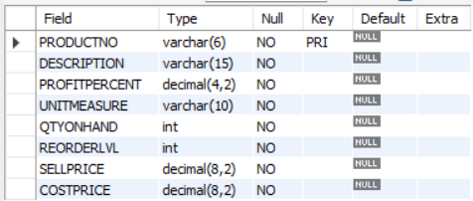

# Table Name: SALESMAN_MASTER _1

**Description:** used to store salesman information working for the company.

|  |  |  |  |
| --- | --- | --- | --- |
| **Column name** | **data type** | **Size** | **Attributes** |
| SALESMANNO | Varchar | 6 | Primary Key/ first letter must start with ‘S’ |
| SALESMANNAME | Varchar | 20 | Not Null |
| ADDRESS 1 | Varchar | 30 | Not Null |
| ADDRESS 2 | Varchar | 30 |  |
| CITY | Varchar | 20 |  |
| PINCODE | Integer | 8 |  |
| STATE | Varchar | 20 |  |
| SALAMT | Real | 8,2 | Not Null , Cannot be 0 |
| TGTTOGET | Decimal | 6,2 | Not Null , Cannot be 0 |

|  |  |  |  |
| --- | --- | --- | --- |
| YTDSALES | Double | 6,2 | Not Null |
| REMARKS | Varchar | 60 |  |

**Query:**

create table SALESMAN_MASTER_1(

SALESMANNO varchar(6) primary key,

SALESMANNAME varchar(20) not null,

ADDRESS1 varchar(30) not null,

ADDRESS2 varchar(30),

CITY varchar(20),

PINCODE int(8),

STATE varchar(20),

SALAMT real(8,2) not null,

TGTTOGET decimal(6,2) not null,

YTDSALES double(6,2) not null,

REMARKS varchar(60),

constraint sno_chk check(SALESMANNO like 'S%'),

constraint samt_chk check(SALAMT != 0),

constraint tgt_chk check(TGTTOGET != 0)

);

desc SALESMAN_MASTER_1;

**Output:**

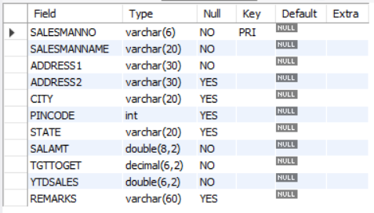

# Reinsert the data in these three tables based upon Lab 2.

**Query:**

insert into CLIENT_MASTER_1 values("C00001","Ivan bayross",null,null,"Mumbai",400054,"Maharashtra",15000);

insert into CLIENT_MASTER_1 values("C00002","Mamta muzumdar",null,null,"Madras",780001,"Tamil Nadu",0);

insert into CLIENT_MASTER_1 values("C00003","Chhaya bankar",null,null,"Mumbai",400057,"Maharashtra",5000);

insert into CLIENT_MASTER_1 values("C00004","Ashwini joshi",null,null,"Bangalore",560001,"Karnataka",0);

insert into CLIENT_MASTER_1 values("C00005","Hansel colaco",null,null,"Mumbai",400060,"Maharashtra",2000);

insert into CLIENT_MASTER_1 values("C00006","Deepak sharma",null,null,"Mangalore",560050,"Karnataka",0);

select * from CLIENT_MASTER_1;

**Output:**

# 

**Query:**

# insert into PRODUCT_MASTER_1 values("P00001","T-Shirt",5,"Piece",200,50,350,250);

# insert into PRODUCT_MASTER_1 values("P0345","Shirts",6,"Piece",150,50,500,350);

# insert into PRODUCT_MASTER_1 values("P06734","Cotton jeans",5,"Piece",100,20,600,450);

# insert into PRODUCT_MASTER_1 values("P07865","Jeans",5,"Piece",100,20,750,500);

# insert into PRODUCT_MASTER_1 values("P07868","Trousers",2,"Piece",150,50,850,550);

# insert into PRODUCT_MASTER_1 values("P07885","Pull Overs",2.5,"Piece",80,30,700,450);

# insert into PRODUCT_MASTER_1 values("P07965","Denim jeans",4,"Piece",100,40,350,250);

# insert into PRODUCT_MASTER_1 values("P07975","Lycra tops",5,"Piece",70,30,300,175);

# insert into PRODUCT_MASTER_1 values("P08865","Skirts",5,"Piece",75,30,450,300);

# select * from PRODUCT_MASTER_1;

**Output:**

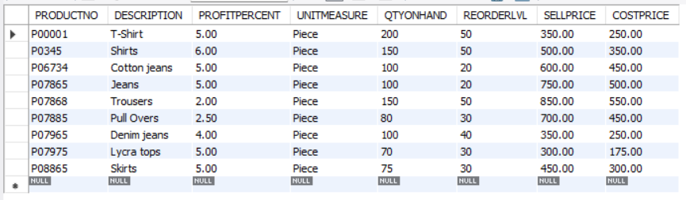

**Query:**

insert into SALESMAN_MASTER_1 values("S00001","Aman","A/14","Worli","Mumbai",400002,"Maharashtra",3000,100,50,"Good");

insert into SALESMAN_MASTER_1 values("S00002","Omkar","65","Nariman","Mumbai",400001,"Maharashtra",3000,200,100,"Good");

insert into SALESMAN_MASTER_1 values("S00003","Raj","P-7","Bandra","Mumbai",400032,"Maharashtra",3000,200,100,"Good");

insert into SALESMAN_MASTER_1 values("S00004","Ashish","A/5","Juhu","Mumbai",400044,"Maharashtra",3500,200,150,"Good");

select * from SALESMAN_MASTER_1;

**Output:**

